January 6, 2023

Dear Parents and Community Members:

We are pleased to present you with the Annual Education Report (AER), which provides key information on the 2022-23 educational progress for Holland High School. The AER addresses the complex reporting information required by federal and state laws. The school’s report contains information about student assessment, accountability, and teacher quality. If you have any questions about the AER, please contact Andrea Mehall for assistance.

The AER is available for you to review electronically by visiting the following website https://www.mischooldata.org/, or you may review a copy in the main office at your child’s school.

For the 2022-23 school year, schools were identified based on previous years’ performance using definitions and labels as required in Every Student Succeeds Act (ESSA). A Targeted Support and Improvement (TSI) school is one that had at least one underperforming student subgroup in 2021-22. An Additional Targeted Support (ATS) school is one that had a student subgroup performing at the same level as the lowest 5% of all schools in the state in 2021-22. A Comprehensive Support and Improvement (CSI) school is one whose performance was in the lowest 5% of all schools in the state or had a graduation rate at or below 67% in 2021-22. Some schools are not identified with any of these labels. In these cases, no label is given.

Our school was identified as an Comprehensive Support and Improvement (CSI) for 22-23 based on previous results.

Holland High School administers the SAT, M-STEP, and WorkKeys assessments to all 11th grade students. Over the past two years, the data trend that has emerged is the discrepancy between racial/ethnic groups who are assessed. Proficiency data for the 2022 administration of the SAT and M-STEP are included in the tables below.

Demographic Group  (SAT Evidence Based Reading and Writing:2022) | Percent Proficient  (n=number of total students tested)
White | 71% (n=69)
Black / African-American | 15.4% (n=13)
Hispanic | 32% (n=84)

Demographic Group  (SAT Math:2022) | Percent Proficient  (n=number of total students tested)
White | 40.6% (n=69)
Black / African-American | 0% (n=13)
Hispanic | 6% (n=84)

Demographic Group (M-STEP, 2022) | Percent Proficient  (n=number of total students tested)
White (M-STEP Science) | 57.6% (n=66)
Black / African-American (M-STEP Science) | 16.7% (n=12)
Hispanic (M-STEP Science) | 25.6% (n=78)
White (M-STEP Social Studies) | 60.6% (n=66)
Black / African-American (M-STEP Social Studies) | 8.3% (n=12)
Hispanic (M-STEP Social Studies) | 36.4% (n=77)

Our school is addressing these discrepancies in multiple ways. Through our Positive Behavior Supports and Interventions efforts, Holland High School is identifying ways to better support students socially and emotionally, so that they feel confident in their classes. Efforts include recognizing achievement in the areas of grades, behavior, and attendance. Additionally, students who have demonstrated a need beyond our school wide efforts are supported through on-site mental health therapists, check-in / check-out, after-school tutoring, and a specific Math intervention Advisory.

Additionally, staff professional development has been focused on instructional pedagogy, guaranteed viable curriculum, social competency, and equitable grading practices. Regular communication is shared with staff regarding opportunities for growth in the area of diversity, equity, and inclusion, and heritage months are celebrated publicly. Key personnel have been trained in Crisis Prevention and Intervention, with a focus on verbal deescalation techniques, and the majority of teachers at Holland High School have been trained in Restorative Practices, and teachers are asked to incorporate Circles into their classroom instruction.
In these ways, the achievement gaps referenced above are being acknowledged and addressed at Holland High School.

State law requires that we also report additional information.
- PROCESS FOR ASSIGNING PUPILS TO THE SCHOOL
Board Policy 5120 - ASSIGNMENT TO SCHOOL, CLASS, AND GRADE for Holland Public Schools

The following guidelines shall be followed in assigning students to schools, classes, and grades. All inquiries regarding elementary and secondary school boundaries are to be directed to the Superintendent.

- School Assignment/Transfer
  - Fundamentally, student assignment to a school shall be determined by attendance areas. Such areas will be adjusted to balance class size, to maintain racial and socioeconomic balance, and to maintain teacher-student ratios.
  - When feasible, children in the same family will be assigned to the same school, but children may be assigned to different schools when they live in a divided area, an overloaded area, or when requested by a parent and they can provide their own transportation.
  - Whenever possible, commitments made, in writing, to parents in earlier years - either implicitly by tradition or verbally - will be given priority in the process of assigning students for the year ahead. Placement policies and individual placements will be reviewed annually and adjusted when necessary.
  - When parents request that their child attend a school other than the one in their attendance area, they will be asked to sign the Student Transfer Agreement.
  - When families relocate from one neighborhood to another within the District during the school year, the children affected may continue their education at their original school if parents provide transportation to/from school.
- Class and Grade Assignment/Transfer
  - Assignments to class and grade shall be made by the principal after consultation with relevant staff.
  - Placement will be based on several factors including the intellectual, physical, social, and emotional development of the student as revealed by the use of available data and observations of the staff.
  - Each principal shall establish the criteria, including the intellectual, social, and emotional characteristics, by which students are assigned to classes and/or teachers or are transferred after initial assignment.
- The following procedures shall be followed in a transfer of a student within a school:
  - A written request shall be made to the principal by the parent of the student, a professional staff member, or by a student. Transfer requests may also be initiated by the principal.
  - After consultation with the appropriate personnel, a determination regarding the validity of the request shall be made by the principal.

If the transfer request is initiated by the District or a minor student, parents shall be advised of the request and the reasons it will be beneficial to the student or is necessary to maintain program effectiveness. They shall be advised of their rights of appeal if they do not agree with the transfer.

- THE STATUS OF THE 3-5 YEAR SCHOOL IMPROVEMENT PLAN

The School Improvement Plan at Holland High School includes goals that are rooted in the analysis of our achievement data. This includes academic goals in the content areas of Reading and Mathematics. Additionally, Holland High School has a School Improvement goal of improving the Social Competency. Some of the examples of the ways in which we are working toward meeting these goals include school-wide reading strategies, regular data analysis, instructional feedback and coaching, after-school tutoring, Math intervention Advisory, and numerous activites and structures that celebrate positive student behavior. Holland High School continues to document and monitor goals, strategies, and action steps that aim to improve the quality of instruction and academic achievement.

- A BRIEF DESCRIPTION OF EACH SPECIALIZED SCHOOL
1. Severe Multiple Impairments Classrooms
Two Special Education Programs designed to serve elementary age students with Severe Multiple Disabilities. These classrooms operate according to the regulations defined by the Individuals with Disabilities Education Act (IDEA) and the Michigan Administrative Rules for Special Education (R 340.1748).

2. Early Childhood Special Education Classrooms
Three Special Education Programs designed to serve Preschool age students (3 through 5 years) with Disabilities. These classrooms operate according to the regulations defined by the Individuals with Disabilities Education Act (IDEA) and the Michigan Administrative Rules for Special Education (R 340.1755).

3. Classrooms for students with Hearing Impairments
Three Special Education Programs designed to serve preschool through 12th grade students with Hearing Impairments. These classrooms operate according to the regulations defined by the Individuals with Disabilities Education Act (IDEA) and the Michigan Administrative Rules for Special Education (R 340.1742).

4. Autism Spectrum Disorder Classrooms
Three Special Education Programs designed to serve preschool through 12th grade students with ASD. These classrooms operate according to the regulations defined by the Individuals with Disabilities Education Act (IDEA) and the Michigan Administrative Rules for Special Education (R 340.1758).

- IDENTIFY HOW TO ACCESS A COPY OF THE CORE CURRICULUM, A DESCRIPTION OF ITS IMPLEMENTATION, AND AN EXPLANATION OF THE VARIANCES FROM THE STATE’S MODEL

The framework for developing curriculum is established through the Michigan Department of Education (MDE). Within that framework, local schools adopt the core curriculum as designed, or modify the curriculum to address local needs. Currently, our district has written curriculum maps Pre-K-12 for Math and ELA that are aligned to the Michigan Academic Standards. The Grade Level Content Expectations (GLCE’s) in the area of Social Studies will continue to be used.

Our curriculum is aligned with the State of Michigan content standards, which are contained in the Michigan Academic Standards Page, on the State of Michigan website: https://www.michigan.gov/mde/services/academic-standards

Pacing guides and curriculum guides are available on the district website or through the Office of School Improvement. Holland Public Schools has a defined guaranteed and viable curriculum for all students and core instruction time is held at a high standard.

- THE AGGREGATE STUDENT ACHIEVEMENT RESULTS FOR ANY LOCAL COMPETENCY TESTS OR NATIONALLY NORMED ACHIEVEMENT TESTS

The following data tables include assessment data from the following tests:
- School-Day Administration of SAT Plus Writing for Grade 11 (April, 2022)
- School-Day Administration of PSAT-10 for Grade 10 (Fall 2022)
- School-Day Administration of PSAT 8/9 for Grade 9 (April, 2022)
- STAR Math for Grades 9-11 (Fall, 2022)
- STAR Reading for Grades 9-11 (Fall, 2022)

School-Day Administration of SAT Plus Writing for Grade 11 (April, 2022)

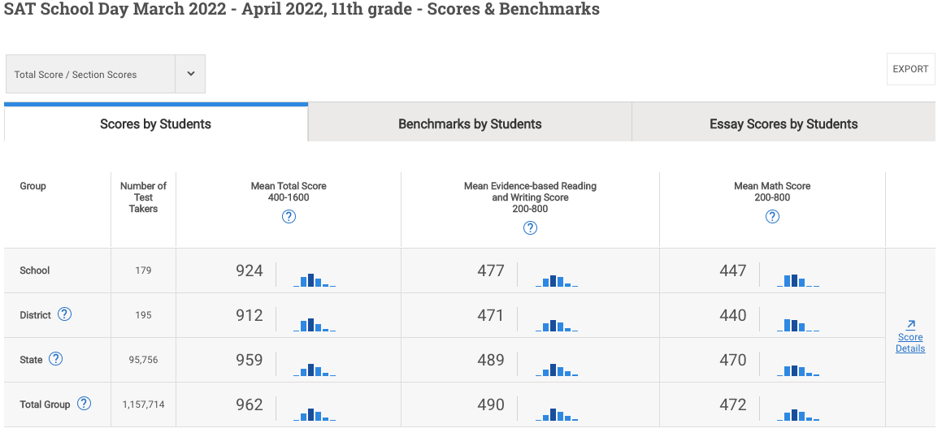
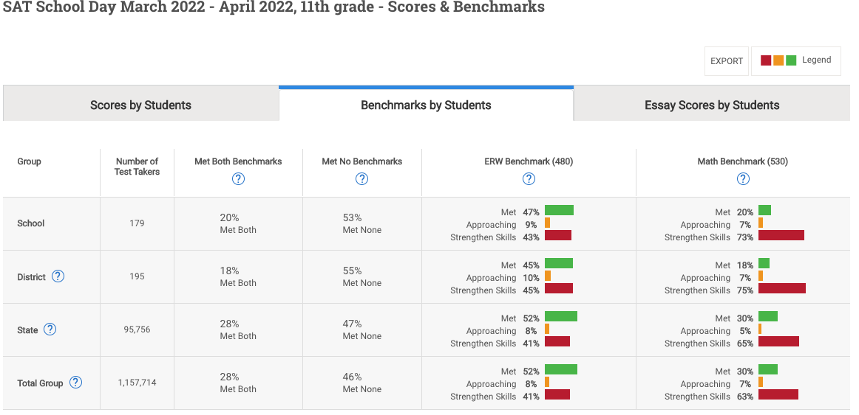
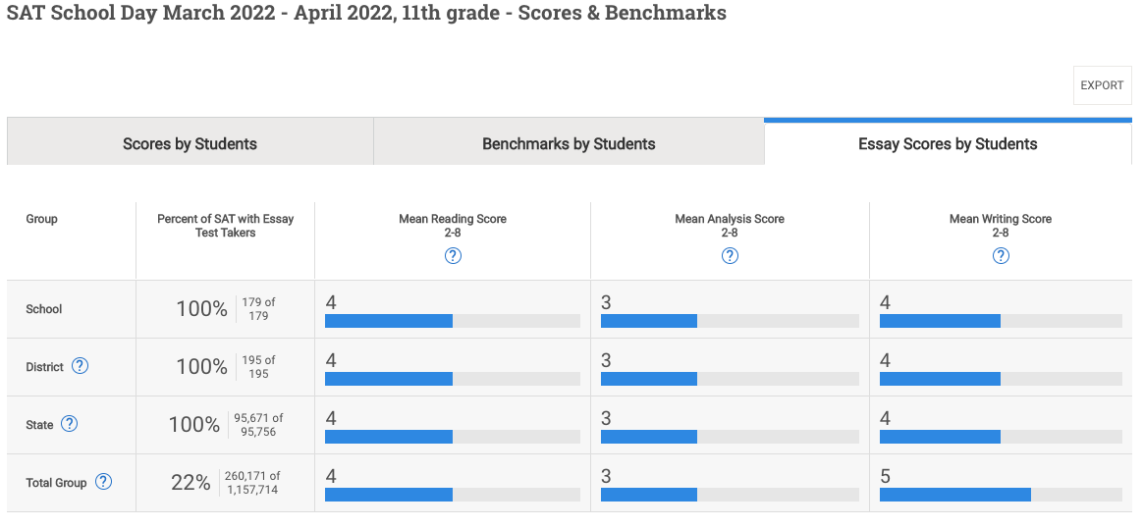

School-Day Administration of PSAT-10 for Grade 10 (Fall 2022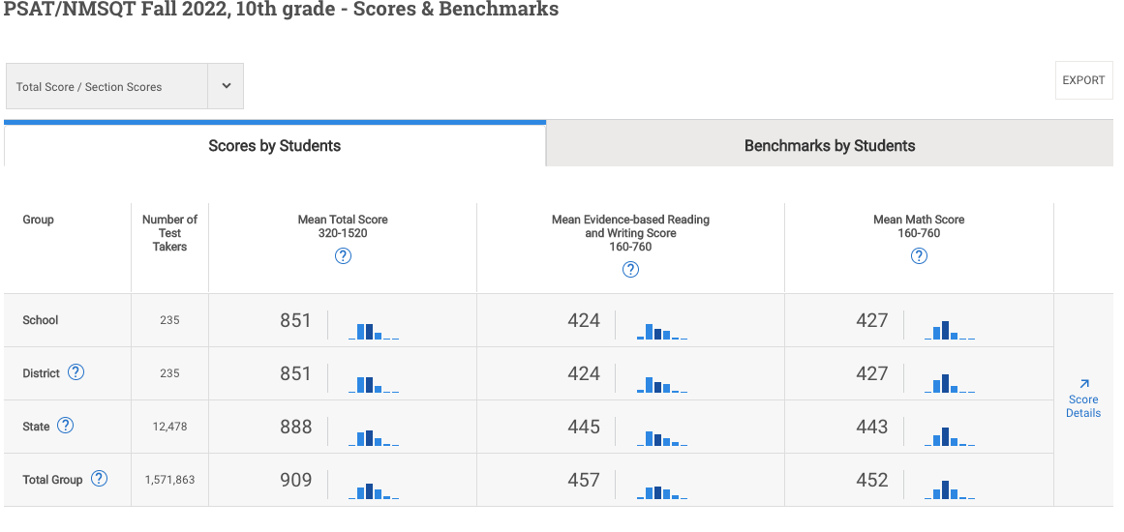

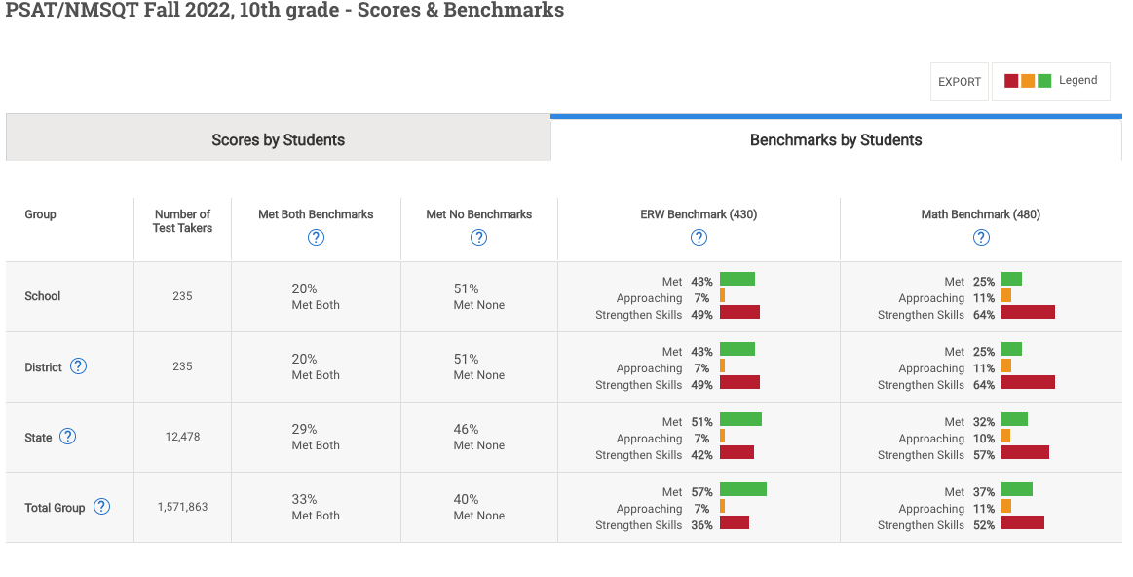

School-Day Administration of PSAT-8/9 for Grade 9 (April, 2022)

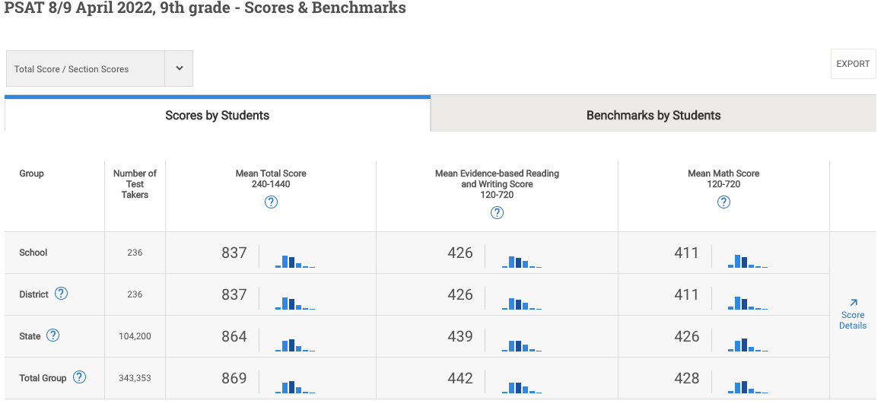

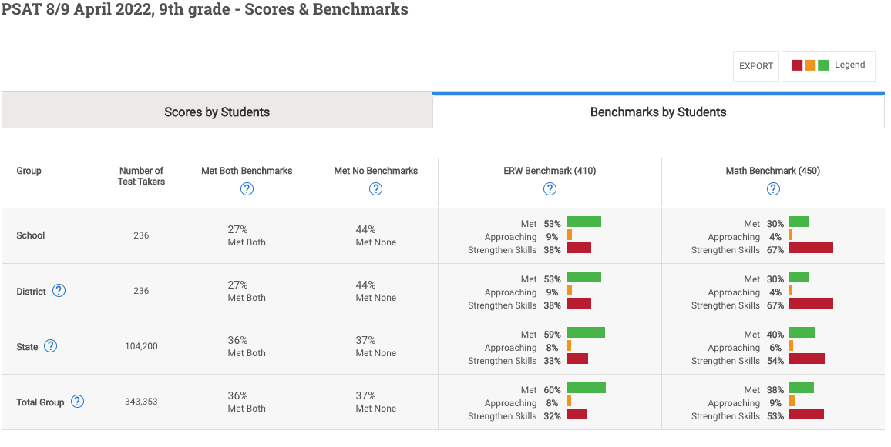

STAR Math Data

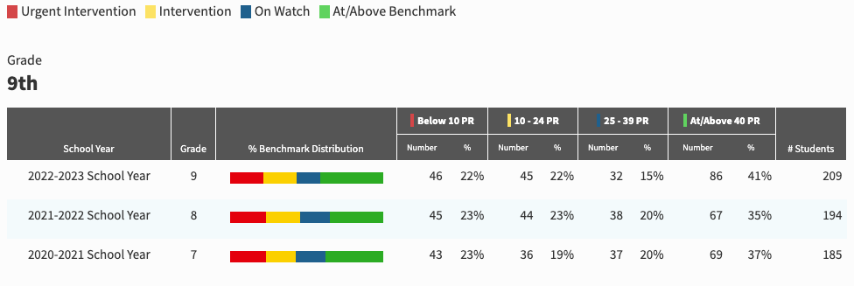

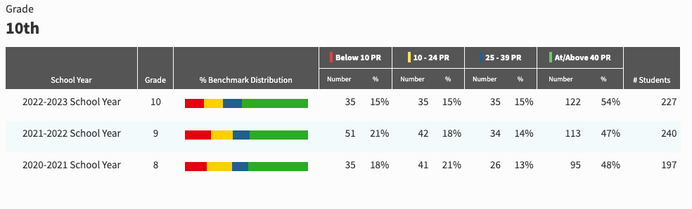

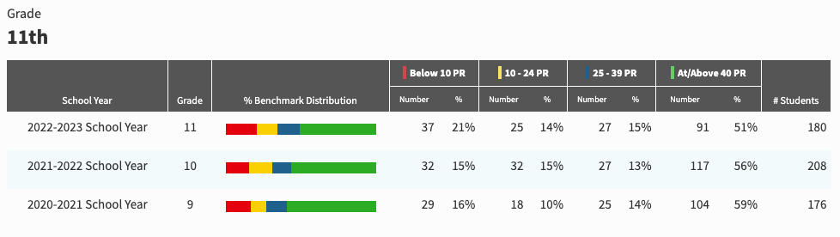

STAR Reading Data

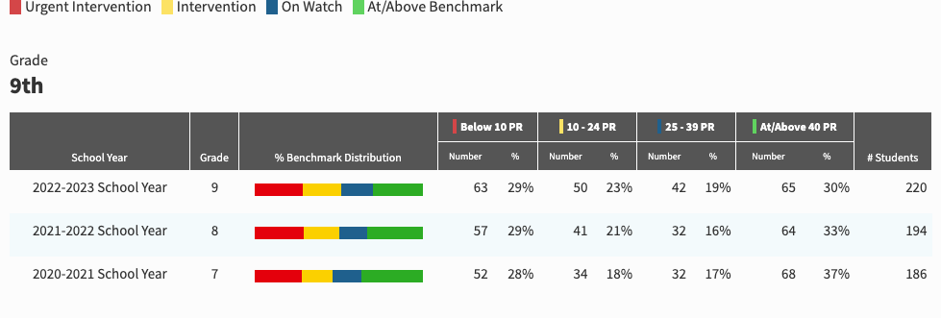

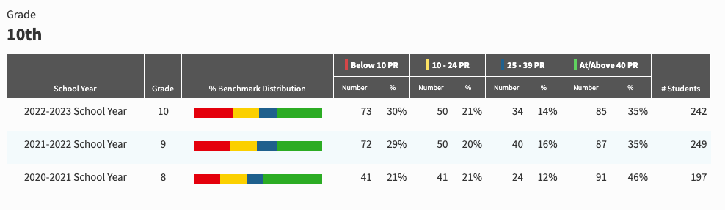

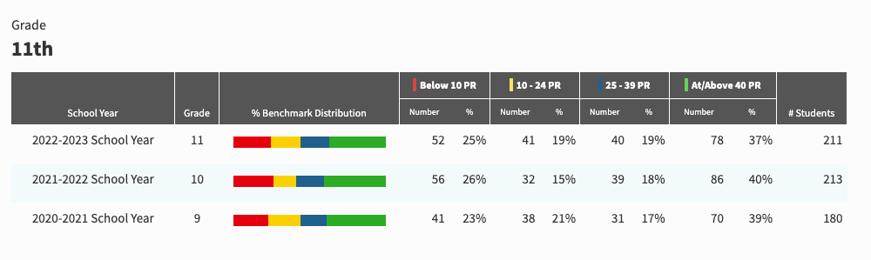

- IDENTIFY THE NUMBER AND PERCENT OF STUDENTS REPRESENTED BY PARENTS AT PARENT-TEACHER CONFERENCES

Conference Session | Number of Conferences Held | Percentage of Students Represented
Fall, 2019 | 1,541 | 27%
Fall, 2020 | 981 | 20%
Fall, 2021 (Student-Led) | 561 | 55.7%
Fall, 2022 (Student-Led) | 474 | 58%

- FOR HIGH SCHOOLS, ONLY ALSO REPORT ON THE FOLLOWING:
  - THE NUMBER AND PERCENT OF POSTSECONDARY ENROLLMENTS (DUAL ENROLLMENT)

School Year | Number of Students in Dual Enrollment* | Percent of Enrolled Students
2019-2020 | 11 | 0.97%
2020-2021 | 15 | 1.40%
2021-2022 | 14 | 1.35%
2022-2023 | 22 | 2.27%
*The data in the table above does not include the students enrolled in Davenport University courses through Holland Early College.

  - THE NUMBER OF COLLEGE EQUIVALENT COURSES OFFERED (AP/IB)
Holland High School offers twelve (12) Advanced Placement courses. Three of these courses are offered on an every-other-year basis in order to ensure sustainable enrollment (AP Biology, AP Chemistry, AP Physics). The remaining courses are offered annually. These include AP Calculus, AP English Language and Composition, AP English Literature and Composition, AP Psychology, AP Statistics, AP U.S. Government, AP World History, and AP Spanish Language and Culture.

  - THE NUMBER AND PERCENTAGE OF STUDENTS ENROLLED IN COLLEGE EQUIVALENT COURSES (AP/IB)

Subject | Number of Students Enrolled - 2022 | Number of Students Enrolled - 2021 | Number of Students Enrolled - 2020 | Number of Students Enrolled - 2019
AP Biology | 52 | Class not offered in 2020-2021. | 54 | Class not offered in 2018-2019.
AP Calculus | 25 | 26 | 36 | 42
AP Chemistry | Class not offered in 2021-2022 | 36 | Class not offered in 2019-2020. | 37
AP English Language and Composition | 52 | 48 | 73 | 67
AP English Literature and Composition | 17 | 31 | 40 | 51
AP Human Geography | Class not offered in 2021-2022 | 22 | Class not offered in 2019-2020. | 27
AP Physics | Class not offered in 2021-2022 | 19 | Class not offered in 2019-2020. | 15
AP Psychology | 24 | 51 | 56 | 58
AP Statistics | 45 | 48 | 54 | 70
AP U.S. Government | 79 | 40 | 84 | 97
AP U.S. History | Class not offered in 2021-2022 | Class not offered in 2020-2021. | Class not offered in 2019-2020. | 20
AP World History | 47 | 57 | 56 | 77
AP Spanish Language and Culture | 22 | Class not offered in 2020-2021. | Class not offered in 2019-2020. | Class not offered in 2018-2019.

Subject | Percentage of Total Students Enrolled - 2022  (n=977) | Percentage of Total Students Enrolled - 2021 (n=1,032) | Percentage of Total Students Enrolled - 2020 (n=1,065) | Percentage of Total Students Enrolled - 2019 (n=1,130)
AP Biology | 5.3% | Class not offered in 2020-2021. | 5.0% | Class not offered in 2018-2019.
AP Calculus | 2.55% | 2.5% | 3.4% | 3.7%
AP Chemistry | Class not offered in 2021-2022 | 3.4% | Class not offered in 2019-2020. | 3.2%
AP English Language and Composition | 5.3% | 4.6% | 6.8% | 5.9%
AP English Literature and Composition | 1.74% | 3.0% | 3.7% | 4.5%
AP Human Geography | Class not offered in 2021-2022 | 2.1% | Class not offered in 2019-2020. | 2.3%
AP Physics | Class not offered in 2021-2022 | 1.8% | Class not offered in 2019-2020. | 1.3%
AP Psychology | 2.45% | 4.9% | 5.2% | 5.1%
AP Statistics | 4.6% | 4.6% | 5.0% | 6.2%
AP U.S. Government | 8.08% | 3.8% | 7.9% | 8.6%
AP U.S. History | Class not offered in 2021-2022 | Class not offered in 2020-2021. | Class not offered in 2019-2020. | 1.7%
AP World History | 4.8% | 5.5% | 5.2% | 6.8%
AP Spanish | 2.25% | Class not offered in 2020-2021. | Class not offered in 2019-2020. | Class not offered in 2018-2019.

  - THE NUMBER AND PERCENTAGE OF STUDENTS RECEIVING A SCORE LEADING TO COLLEGE CREDIT

Subject | 3 or higher - 2022 | 3 or higher - 2021 | 3 or higher - 2020 | 3 or higher - 2019
AP Biology | 71% (n=22) | Class not offered in 2020-2021. | 63.9% (n=23) | Class not offered in 2018-2019.
AP Calculus | 17.6% (n=3) | 23.5% (n=4) | 61.5% (n=16) | 59.3% (n=16)
AP Chemistry | Class not offered in 2021-2022. | 17.9% (n=5) | Class not offered in 2019-2020. | 32.0% (n=8)
AP English Language and Composition | 57.5% (n=19) | 68.4% (n=26) | 55.6% (n=25) | 38.8% (n=19)
AP English Literature and Composition | 70% (n=7) | 23.1% (n=3) | 50.0% (n=12) | 45.2% (19)
AP Human Geography | Class not offered in 2021-2022. | 7.7% (n=1) | Class not offered in 2019-2020. | 6.3% (n=1)
AP Physics | Class not offered in 2021-2022. | 55.6% (n=5) | Class not offered in 2019-2020. | 40.0% (n=4)
AP Psychology | 68.7% (n-11) | 81.8% (n=10) | 50.0% (n=14) | 68.6% (n=24)
AP Statistics | 27.2% (n=6) | 40.0% (n=2) | 30.0% (n=3) | 50.0% (n=14)
AP U.S. Government | 10.2% (n=4) | 19.4% (n=6) | 30.5% (n=18) | 22.6% (n=14)
AP U.S. History | Class not offered in 2021-2022. | Class not offered in 2020-2021. | Class not offered in 2019-2020. | 53.8% (n=7)
AP World History | 51.4% (n=18) | 22.9% (n=8) | 44.7% (n=17) | 47.6% (n=20)

The future is bright for Holland High School, and the measures that have been put in place will undoubtedly put HHS on the path to closing our achievement gaps and preparing our students for college and career readiness. If you have any questions about the information contained in this letter, please do not hesitate to contact me at amehall@hollandpublicschools.org or (616) 494-2200.

Sincerely,

Andrea Mehall
Holland High School Principal

