January 6, 2023

Dear Parents and Community Members:

We are pleased to present you with the Annual Education Report (AER), which provides key information on the 2022-23 educational progress for Holland Language Academy. The AER addresses the complex reporting information required by federal and state laws. The school’s report contains information about student assessment, accountability, and teacher quality. If you have any questions about the AER, please contact Iliana Vasquez for assistance.

The AER is available for you to review electronically by visiting the following website https://www.mischooldata.org/, or you may review a copy in the main office at your child’s school.

For the 2022-23 school year, schools were identified based on previous years’ performance using definitions and labels as required in Every Student Succeeds Act (ESSA). A Targeted Support and Improvement (TSI) school is one that had at least one underperforming student subgroup in 2021-22. An Additional Targeted Support (ATS) school is one that had a student subgroup performing at the same level as the lowest 5% of all schools in the state in 2021-22. A Comprehensive Support and Improvement (CSI) school is one whose performance was in the lowest 5% of all schools in the state or had a graduation rate at or below 67% in 2021-22. Some schools are not identified with any of these labels. In these cases, no label is given.

Our school was identified as a School that has not been given a label.

Based on comparative M-STEP data from 2018-19 and 2020-21, there was an overall decrease in performance in both ELA and Mathematics for participating students in grades third through fifth. The results are not alarming, as this is something that was expected as a result of teaching, learning and testing through a pandemic. Although, there was a decrease in our overall percent of students achieving proficiently, the greatest need continues to be in math.

For this reason,we utilize Tier II providers and Instructional assistants to primarily focus on supporting math instruction. Based on achievement data, our focus will remain in increasing student outcomes in this area.

State law requires that we also report additional information.
- PROCESS FOR ASSIGNING PUPILS TO THE SCHOOL
Board Policy 5120 - ASSIGNMENT TO SCHOOL, CLASS, AND GRADE for Holland Public Schools

The following guidelines shall be followed in assigning students to schools, classes, and grades. All inquiries regarding elementary and secondary school boundaries are to be directed to the Superintendent.

- School Assignment/Transfer
  - Fundamentally, student assignment to a school shall be determined by attendance areas. Such areas will be adjusted to balance class size, to maintain racial and socioeconomic balance, and to maintain teacher-student ratios.
  - When feasible, children in the same family will be assigned to the same school, but children may be assigned to different schools when they live in a divided area, an overloaded area, or when requested by a parent and they can provide their own transportation.
  - Whenever possible, commitments made, in writing, to parents in earlier years - either implicitly by tradition or verbally - will be given priority in the process of assigning students for the year ahead. Placement policies and individual placements will be reviewed annually and adjusted when necessary.
  - When parents request that their child attend a school other than the one in their attendance area, they will be asked to sign the Student Transfer Agreement.
  - When families relocate from one neighborhood to another within the District during the school year, the children affected may continue their education at their original school if parents provide transportation to/from school.
- Class and Grade Assignment/Transfer
  - Assignments to class and grade shall be made by the principal after consultation with relevant staff.
  - Placement will be based on several factors including the intellectual, physical, social, and emotional development of the student as revealed by the use of available data and observations of the staff.
  - Each principal shall establish the criteria, including the intellectual, social, and emotional characteristics, by which students are assigned to classes and/or teachers or are transferred after initial assignment.
- The following procedures shall be followed in a transfer of a student within a school:
  - A written request shall be made to the principal by the parent of the student, a professional staff member, or by a student. Transfer requests may also be initiated by the principal.
  - After consultation with the appropriate personnel, a determination regarding the validity of the request shall be made by the principal.

If the transfer request is initiated by the District or a minor student, parents shall be advised of the request and the reasons it will be beneficial to the student or is necessary to maintain program effectiveness. They shall be advised of their rights of appeal if they do not agree with the transfer.
- THE STATUS OF THE 3-5 YEAR SCHOOL IMPROVEMENT PLAN
HLA continues to implement the School Improvement Plan created for the 2019-2020 school year, with modifications made for the 2020-2021 school year. We will be working on updating our plan to reflect current needs for the upcoming 2022-2023 school year.

- A BRIEF DESCRIPTION OF EACH SPECIALIZED SCHOOL
1. Severe Multiple Impairments Classrooms

Two Special Education Programs designed to serve elementary age students with Severe Multiple Disabilities. These classrooms operate according to the regulations defined by the Individuals with Disabilities Education Act (IDEA) and the Michigan Administrative Rules for Special Education (R 340.1748).

2. Early Childhood Special Education Classrooms

Three Special Education Programs designed to serve Preschool age students (3 through 5 years) with Disabilities. These classrooms operate according to the regulations defined by the Individuals with Disabilities Education Act (IDEA) and the Michigan Administrative Rules for Special Education (R 340.1755).

3. Classrooms for students with Hearing Impairments

Three Special Education Programs designed to serve preschool through 12th grade students with Hearing Impairments. These classrooms operate according to the regulations defined by the Individuals with Disabilities Education Act (IDEA) and the Michigan Administrative Rules for Special Education (R 340.1742).

4. Autism Spectrum Disorder Classrooms

Three Special Education Programs designed to serve preschool through 12th grade students with ASD. These classrooms operate according to the regulations defined by the Individuals with Disabilities Education Act (IDEA) and the Michigan Administrative Rules for Special Education (R 340.1758).
- IDENTIFY HOW TO ACCESS A COPY OF THE CORE CURRICULUM, A DESCRIPTION OF ITS IMPLEMENTATION, AND AN EXPLANATION OF THE VARIANCES FROM THE STATE’S MODEL
The framework for developing curriculum is established through the Michigan Department of Education (MDE). Within that framework, local schools adopt the core curriculum as designed, or modify the curriculum to address local needs. Currently, our district has written curriculum maps Pre-K-12 for Math and ELA that are aligned to the Michigan Academic Standards. The Grade Level Content Expectations (GLCE’s) in the area of Social Studies will continue to be used through 2020.

Our curriculum is aligned with the State of Michigan content standards, which are contained in the Michigan Academic Standards Page, on the State of Michigan website: http://www.michigan.gov/mde/0,4615,7-140-28753_64839_65510---,00.html.
Pacing guides and curriculum guides are available on the district website or through the Office of School Improvement. Holland Public Schools has a defined guaranteed and viable curriculum for all students and core instruction time is held at a high standard.
- THE AGGREGATE STUDENT ACHIEVEMENT RESULTS FOR ANY LOCAL COMPETENCY TESTS OR NATIONALLY NORMED ACHIEVEMENT TESTS

ELA
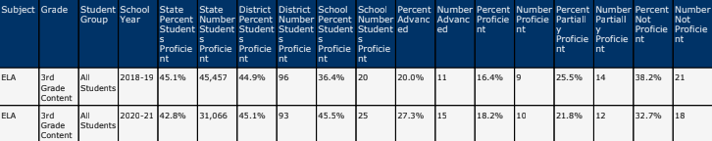
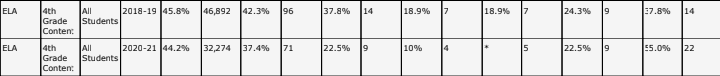
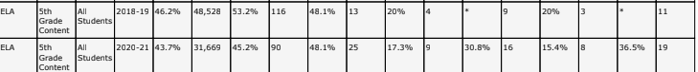
MATH
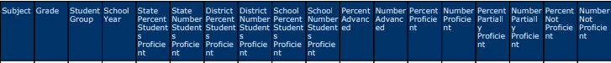
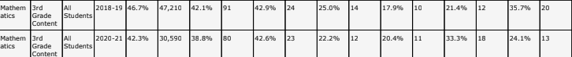
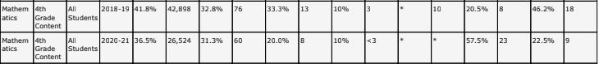
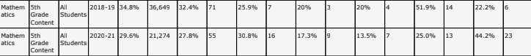
- IDENTIFY THE NUMBER AND PERCENT OF STUDENTS REPRESENTED BY PARENTS AT PARENT-TEACHER CONFERENCES
In Spring 2020, there were a total of 323 enrolled, of which 55 students were online learners. 314 of those students were represented by parent/guardians attending Virtual Parent-Teacher Conferences, for a total of 97 % Participation. The trajectory for PTC participation for HLA has been between 96-98%.

Holland Language Academy’s dynamic staff has proven to rise above all adversity that has been brought about by teaching through a pandemic, despite that, staff remains committed to student achievement. We are extremely grateful for the adaptability and flexibility that has been displayed by both students and staff as we’ve had to pivot between online and in-person learning Pandemic or not, our focus will be student achievement.

Sincerely,

Iliana Vasquez
Holland Language Academy

